ABSTRACT
Smart parking management helps drivers find and reserve available parking spaces while allowing space owners to list unused parking areas. This project, AI-Based Smart Parking Management System, combines a web application, a backend service, a database and laptop-camera-based vehicle detection to manage two parking slots. The system supports three roles: customer, parking-space owner and administrator. Customers can view available approved spaces, book a slot, cancel a booking and access booking details. Owners can submit parking-space information for review, while administrators approve or decline submissions before they become visible to customers. A camera module using computer vision can identify vehicle presence in the configured parking regions and update the software occupancy status. The project also includes a chatbot concept for answering parking questions, checking nearby availability and initiating booking or cancellation through the application workflow. The report documents the design-thinking process, system architecture, software components, user roles, booking flow, validation plan and future improvements. Detection performance depends on camera placement, lighting, occlusion and model configuration; therefore, occupancy decisions should be tested under realistic conditions.
The report documents the motivation for smarter parking, existing parking approaches, user needs, the proposed design, software integration, camera-based occupancy detection, web interaction, implementation observations and planned validation. It distinguishes the described features from future improvements: more parking spaces, stronger location services, robust camera performance in varied conditions, deployment hardening and broader real-world testing remain future extensions.
Keywords: Smart Parking, Computer Vision, OpenCV, YOLO, Flask, Database Management, Slot Booking, Parking Owner, Administrator, Chatbot, Vehicle Detection.

TABLE OF CONTENTS
CHAPTER NO. TITLE PAGE NO.
ABSTRACT i
LIST OF TABLES iv
LIST OF FIGURES v
LIST OF ABBREVIATIONS vi
1. INTRODUCTION 1
1.1 Background and Motivation 1
1.2 Design Thinking Approach – An Overview 2
1.3 Objectives of the Project 4
1.4 Scope of the Project 4
1.5 Organisation of the Report 5
2. STUDY OF EXISTING SOLUTIONS 6
2.1 Existing Products / Solutions 6
2.2 Gaps Identified 7
2.3 Summary 8
3. EMPATHIZE – UNDERSTANDING THE USERS 9
3.1 User Identification 9
3.2 User Research Methods 9
3.2.1 User Context and Needs 10
3.3 Empathy Map 11
3.4 Key Insights 12
4. DEFINE – FRAMING THE PROBLEM 13
4.1 Problem Statement Canvas 13
4.2 How Might We (HMW) Statements 14

5. IDEATE – GENERATING SOLUTIONS 16
5.1 Brainstorming 16
5.2 Ideation Techniques Used 16
5.2.1 SCAMPER Technique 17
5.2.2 Crazy 8’s 17
5.3 Ideas Generated 18
5.4 Selected Concept 19
6. PROTOTYPE – BUILDING THE SOLUTION 20
6.1 Prototyping Plan 20
6.2 System Architecture / Block Diagram 20
6.3 Hardware and Software Requirements 22
6.4 Design Details 23
6.5 Implementation 26
6.6 Cost Estimation 27
7. TEST – VALIDATION AND FEEDBACK 28
7.1 User Testing 28
7.2 Results and Performance Analysis 29
7.3 Feedback and Refinement 30
7.4 Technology Readiness Level (TRL) Assessment 31
8. IMPACT AND SUSTAINABILITY 33
8.1 Mapping to Sustainable Development Goals (SDGs) 33
8.2 Deployment and Sustainability Model 33
9. CONCLUSION AND FUTURE SCOPE 35
9.1 Conclusion 35
9.2 Future Scope 36
REFERENCES 37
ANNEXURE 39

LIST OF TABLES
TABLE NO. TITLE PAGE NO.
2.1 Comparison of Existing Parking Approaches 7
3.1 Parking User Groups and Needs 9
3.2 User-Context Questions and Expected Insights 10
3.3 Empathy Map Summary 11
4.1 Problem Statement Canvas Summary 13
5.1 SCAMPER Applied to Parking Management 17
5.2 Selected Concepts from Crazy 8’s 18
5.3 Concept Screening and Feasibility 18
6.1 Prototype Development Plan 20
6.2 Hardware Requirements 22
6.3 Software Requirements 22
6.4 web application Sensor and Interface Connections 23
6.5 Measured, Derived and Illustrative Parameters 24
6.6 Prototype Cost Estimate 27
7.1 Functional Test Plan and Observed Status 28
7.2 Illustrative Energy Calculation Example 29
7.3 Feedback and Improvement Grid 31
7.4 TRL Assessment of Smart Parking System 31
8.1 Mapping of the Smart Parking Project to SDGs 33
8.2 Deployment / Sustainability Model 34

LIST OF FIGURES
FIGURE NO. TITLE PAGE NO.
1.1 Design Thinking Process Used in the Project 3
3.1 Parking User Context and Booking Scenario 11
3.2 Empathy Map for a Parking User 11
4.1 Problem Statement Canvas 13
4.2 How Might We Statements 14
5.1 SCAMPER Ideation Sheet 17
5.2 Crazy 8’s Concept Sketches 18
6.1 Smart Parking System System Block Diagram 21
6.2 web application Sampling and App Synchronization Flow 25
6.3 Hardware Prototype Photograph (to be inserted) 26
6.4 Application / Demo Control Screenshot (to be inserted) 27
7.1 Illustrative Parking Status and Booking Flow (illustrative) 30
8.1 Smart Parking Deployment Concept 33

LIST OF ABBREVIATIONS
AC Alternating Current
camera frame Analog to Digital Converter
API Application Programming Interface
AI Artificial Intelligence
BMC Business Model Canvas
CT Current Transformer
DC Direct Current
DT Design Thinking
GPIO General Purpose Input/Output
IoT Internet of Things
booking status Kilowatt-hour
Smart Parking Smart Parking Management
PCB Printed Circuit Board
PF Power Factor
occupancy Root Mean Square
REST Representational State Transfer
SCT Split-Core Transformer (current camera)
SDG Sustainable Development Goal
UI User Interface
V Volt
W Watt
booking records Watt-hour
network connection Wireless Fidelity
ZMPT Voltage camera module designation
web application Espressif 32-bit microcontroller family
Smart Parking Smart Parking Management
TRL Technology Readiness Level
API Application Programming Interface

CHAPTER 1

INTRODUCTION

1.1 Background and Motivation
Urban areas, campuses, residential streets and commercial spaces often have limited parking availability. Drivers may spend time searching for an empty space, while privately owned or residential parking areas can remain unused. Manual tracking can lead to outdated availability information, duplicate reservations and confusion between drivers and space owners. A smart parking platform can connect customers with approved parking spaces and provide a clearer process for checking availability, booking and cancellation.
Parking occupancy changes when a vehicle enters or leaves a space. A camera-based system can analyze configured regions of interest and use computer vision to estimate whether a slot is occupied. Detection quality can be affected by lighting, camera angle, vehicle overlap, weather and objects partially blocking the view. A practical system therefore needs careful camera positioning, clear slot regions, database synchronization and testing against actual parking scenes.
The Smart Parking System project focuses on two parking slots and a laptop camera for visual occupancy detection. The software uses a web/backend workflow, a database and computer-vision processing, with a YOLO-based detector where configured. The camera is intended for the parking owner and administrator views rather than the customer view. The system also supports customer booking and cancellation, and owner-submitted parking spaces must receive administrator approval before appearing in customer listings.
A key motivation is to make parking availability understandable and actionable. Customers should be able to see approved spaces, availability and booking status without contacting each owner manually. Owners need a separate dashboard to submit and manage their spaces, while administrators need a review workflow to approve or decline applications. A chatbot can provide a convenient natural-language entry point for parking questions and supported booking actions.
The project is named AI-Based Smart Parking Management System. Its central engineering question is: can a simple web platform combine role-based access, owner approval, customer booking and cancellation, and camera-based occupancy detection to make a small parking facility easier to manage?

1.2 Design Thinking Approach – An Overview
Design Thinking is a human-centred and iterative method for understanding a problem, exploring ideas, building prototypes and learning from feedback. In this project, the process is applied to drivers searching for parking and owners managing available spaces. User interviews and testing should be documented only when they have actually been conducted.
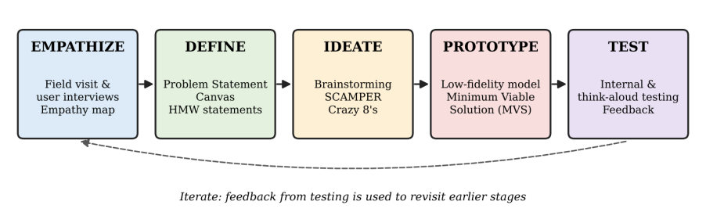
Fig 1.1 Design Thinking Process Used in the Project
- Empathize: Identify drivers who need convenient parking, owners who want to list unused spaces and administrators who verify listings. Understand how each group searches for spaces, manages reservations and handles availability changes.
- Define: Frame the need as a reliable way to discover, approve, reserve and monitor parking spaces while avoiding duplicate bookings and misleading occupancy status.
- Ideate: Explore approaches such as manual parking lists, map-based discovery, camera-based occupancy detection, online booking, owner dashboards, administrator approval and chatbot assistance. Compare affordability, usability, privacy and technical feasibility.
- Prototype: Build a web application with customer, owner and administrator workflows, a database for spaces and bookings, and a laptop-camera module for two parking-slot regions. Integrate computer vision only where the actual implementation supports it.
- Test: Check registration and role access, owner application review, slot availability updates, booking and cancellation, camera occupancy detection, chatbot responses and behaviour during network or database errors. Record actual test evidence rather than assuming every scenario passes.
The cycle is iterative. Calibration findings, camera noise, user feedback and implementation constraints can lead to changes in the circuit, sampling method, interface or problem scope.

1.3 Objectives of the Project
The main objectives of the project are:
- To understand the parking challenges faced by drivers, parking-space owners and administrators.
- To develop a web-based system with separate customer, owner and administrator workflows.
- To maintain parking-space, occupancy and booking information in a database and synchronize updates with the interface.
- To support customer booking and cancellation and an administrator approval process for owner-submitted spaces.
- To validate camera-based occupancy detection, role permissions, booking consistency, chatbot actions and usability, and identify requirements for future expansion.

1.4 Scope of the Project
The present scope is a smart parking prototype focused on two slots, a laptop camera, role-based dashboards, owner application approval, customer booking and cancellation, and database-backed availability. The camera view is restricted to owner and administrator workflows. The chatbot can be integrated with supported backend operations for answering questions, finding nearby parking where location data are available, and handling booking or cancellation intents.
The project does not claim proven large-scale deployment, perfect vehicle detection under every lighting condition, or verified location coverage for every nearby parking query. The current camera setup focuses on two slots, and detection accuracy should be measured with recorded test cases. Future work can extend the number of slots, improve location-based discovery, strengthen security and evaluate the system in a real parking environment.

1.5 Organisation of the Report
Chapter 1 introduces the smart parking problem, project motivation, design-thinking process, objectives and scope. Chapter 2 reviews existing parking approaches and identifies gaps. Chapter 3 considers the needs of customers, owners and administrators. Chapter 4 defines the problem and How Might We questions. Chapter 5 presents ideation and concept selection. Chapter 6 describes the architecture, software, camera detection, database and implementation. Chapter 7 presents validation activities and limitations. Chapter 8 discusses impact and deployment. Chapter 9 concludes and lists future work. References and annexures provide supporting material and project records.

CHAPTER 2

STUDY OF EXISTING SOLUTIONS

2.1 Existing Products / Solutions
Existing parking solutions can be grouped by how availability is published and how reservations are managed. The following overview compares common approaches; actual capabilities vary by implementation.
1. Utility energy meters: A conventional meter measures total energy at the service entrance and is useful for billing. It normally does not identify the contribution of each individual parking space.
2. Plug-in energy meters and smart plugs: These devices measure the power of a single parking space connected through the plug. They can provide useful parking space-level information but require a separate device for each load and may not suit hard-wired parking spaces.
3. Booking record sole-home energy monitors: Current cameras installed at the distribution panel can track aggregate consumption. Some products provide circuit-level monitoring, but parking space identification may require additional cameras or proprietary analytics.
4. Research Smart Parking systems: Smart Parking methods infer parking space states from aggregate camera/occupancy or power traces. Algorithms range from threshold and event-based methods to supervised classification, probabilistic models and deep learning. Their performance depends on parking space diversity, sampling rate, training data and overlapping events.
Table 2.1 Comparison of Existing Parking Approaches
Feature | Manual parking | Online listing | Reservation platform | Camera-assisted system
Availability source | Staff/owner updates | Static listing | Booking database | Camera estimate
Booking support | Manual | Varies | Usually available | Integrated workflow
Owner approval | Manual checks | Varies | Platform review | Administrator approval
Occupancy status | Visual/manual | Often stale | Booking-based | Camera-assisted
Main limitation | Time-consuming | May be outdated | Needs consistent records | Lighting/occlusion
Role in this project | Baseline | Alternative | Core workflow | Two-slot prototype

2.2 Gaps Identified
The study of existing parking approaches highlights several design opportunities and constraints:
- Manual availability updates can become stale when vehicles arrive or leave, causing customers to rely on incorrect information.
- Static listings may not provide a complete booking lifecycle or a clear approval process for owner-submitted spaces.
- Camera-based detection can be affected by lighting, occlusion, camera placement and vehicles crossing slot boundaries; two-slot testing alone does not establish performance at larger facilities.
- A reliable parking application needs clear role permissions, consistent database updates, secure user data and careful handling of camera images. Occupancy results should be tested rather than assumed.
- A useful user interface must distinguish measured, calculated and simulated values, communicate uncertainty.

2.3 Summary
Existing parking approaches range from manual coordination to online reservations and camera-assisted occupancy systems. The proposed project combines a booking workflow with owner approval and camera-based status for two slots. Its contribution is an integrated prototype; larger-scale reliability and detection performance require further testing.

CHAPTER 3

EMPATHIZE – UNDERSTANDING THE USERS

3.1 User Identification
Potential users include drivers who need parking, parking-space owners who want to list unused spaces, and administrators who review listings and manage the platform. The primary customer needs a clear view of approved available spaces and a reliable booking status.
Table 3.1 Parking User Groups and Needs
User Group | Role / Context | Potential Need
Customer / driver | Searches and books parking | Approved spaces, availability and simple booking
Parking-space owner | Submits and manages a space | Separate dashboard and booking details
Administrator | Reviews applications and manages platform | Approve/decline listings and manage access
Developer / operator | Maintains the system | Reliable detection, APIs and database

3.2 User Research Methods
A practical user-research plan combines short interviews with drivers and owners, observation of how parking is currently found and reserved, and task-based testing of the application. Questions should focus on availability trust, ease of booking, cancellation, owner approval and privacy. Include actual findings only when research has been performed.

3.2.1 User Context and Needs
For this report, suggested questions include: How do drivers currently find parking? booking recordsich details matter most—location, price, vehicle type, availability or owner contact? booking recordsat makes a booking difficult? How should owners submit spaces? booking recordsat information should administrators verify? How should camera access and personal data be protected?
- Drivers may want a clear available/occupied status and a simple booking action.
- Owners need a separate dashboard to review their listed spaces and booking activity.
- Customers need confidence that a listed slot is approved and that its availability is current.
- Owner space submission and administrator review should be simple, while camera placement and account permissions must be configured carefully.
- Users may expect camera access to be limited to authorized owner and administrator roles, with clear handling of stored booking and account data.
Table 3.2 User-Context Questions and Expected Insights
Research prompt | What the team should learn
How do you currently find parking? | Maps, enquiries, manual search or existing apps
Which information is most useful? | Location, price, vehicle type, availability and owner details
What makes booking difficult? | Unclear availability, duplicate reservations or cancellation
What should owners be able to manage? | Space details, application status and bookings
What should administrators verify? | Listing details, approval status and misuse reports
What privacy concerns exist? | Camera access, account data and location information

https://drive.google.com/file/d/14_71XvkWBuKz5Mg9fpg9Ts1TsA_rXpt_/view?usp=sharing
Fig 3.1 Parking User Context and Booking Scenario

3.3 Empathy Map
An empathy map can organize the user's statements, thoughts, actions and feelings. The summary below is a design hypothesis for the target user and should be updated using evidence from actual conversations or usability sessions.
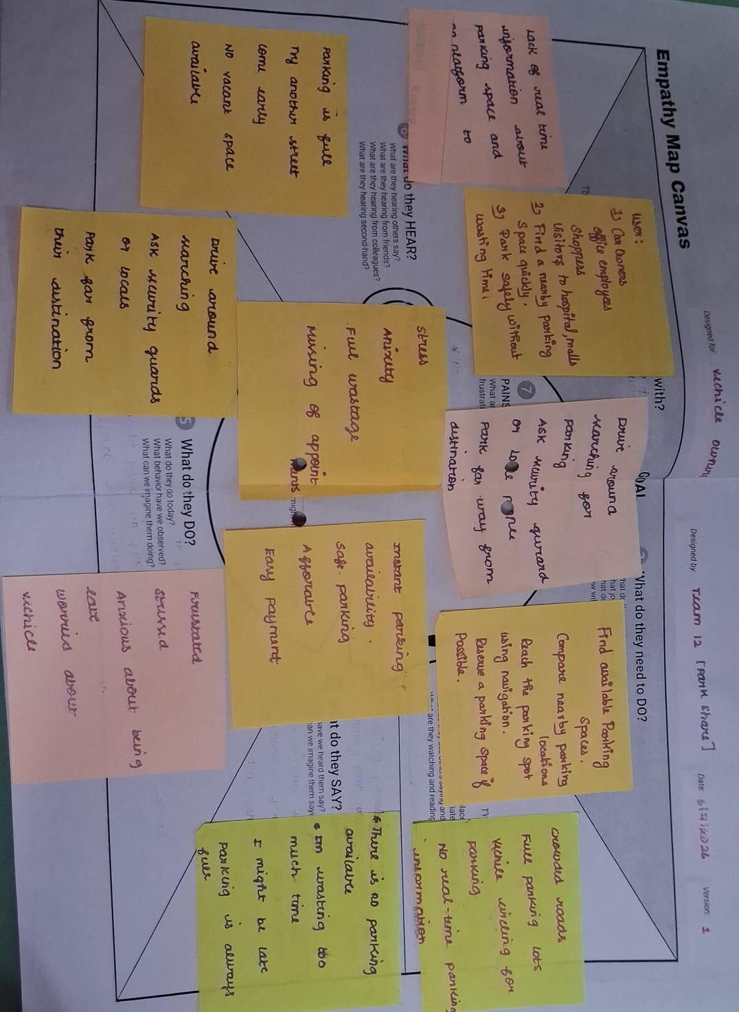
Fig 3.2 Empathy Map for a Parking User
Table 3.3 Empathy Map Summary
Quadrant | Design hypothesis (validate with users)
SAYS | I want to find an available parking space quickly.
THINKS | Can I trust the availability and booking status?
DOES | Searches for parking, checks details and books or cancels.
FEELS | Wants convenience and certainty; may worry about outdated listings.

3.4 Key Insights
The following design insights arise from the problem analysis and should be validated with users:
- Users need clear parking availability and booking status, not just a list of addresses.
- A visible slot status is useful, but camera-based occupancy should be checked against actual parking scenes and should not be treated as infallible.
- The interface should distinguish an owner-submitted application from an administrator-approved listing.
- Reliable occupancy updates require appropriate camera placement, region configuration, detection checks and repeatable testing.
- Parking locations, account details and camera images can be sensitive; role-based access and responsible data handling are important.

CHAPTER 4

DEFINE – FRAMING THE PROBLEM

4.1 Problem Statement Canvas
The problem statement canvas organizes the intended user, need, context, barriers and desired outcome for smart parking.
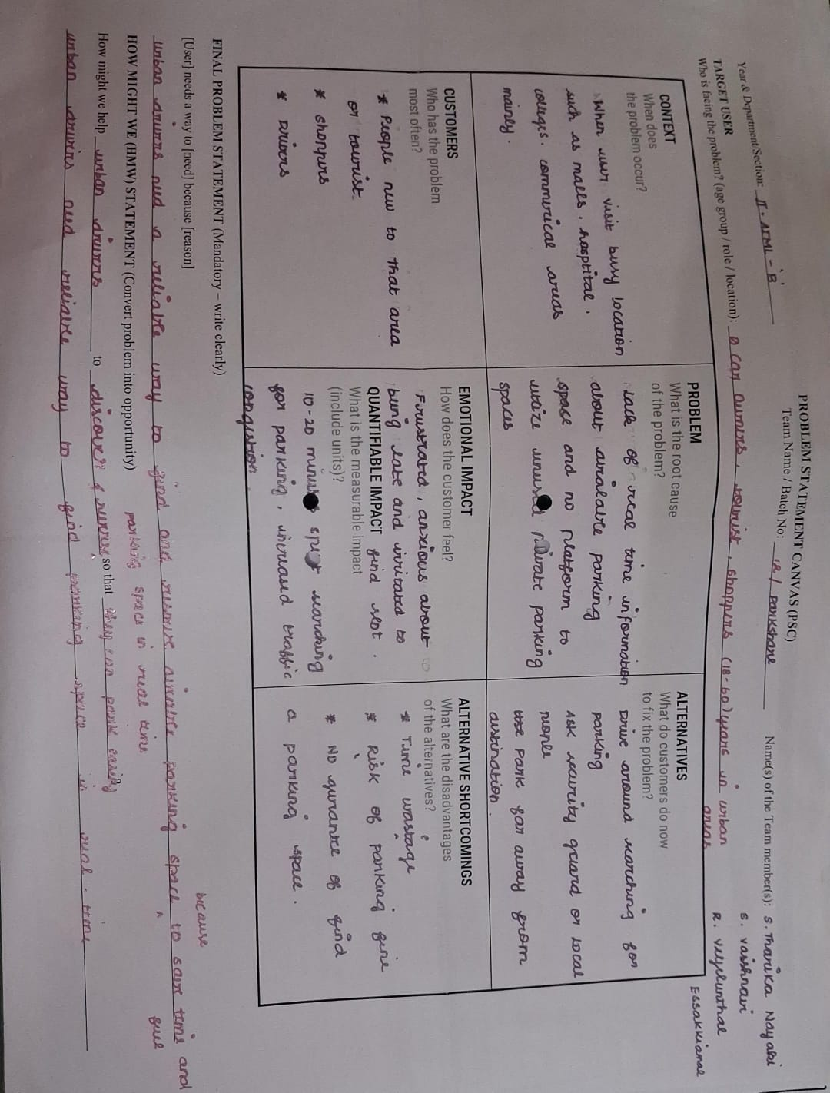
Fig 4.1 Problem Statement Canvas
Table 4.1 Problem Statement Canvas Summary
Canvas Element | Description
Who is affected? | Drivers, parking-space owners and administrators
Need | A reliable way to discover, approve and reserve spaces
Context | Manual search and static listings can be outdated
Barrier | Incorrect occupancy, duplicate bookings and unclear approvals
Current alternatives | Manual coordination, maps and parking applications
Desired outcome | Clear approved listings and consistent booking status
Constraint | Prototype focuses on two camera-monitored slots

Final Problem Statement: Drivers need an accessible way to find and reserve available parking, while owners need a simple way to list unused spaces and administrators need to verify those listings. Manual updates and fragmented communication can create uncertainty, so a role-based application with booking management and camera-assisted occupancy can improve clarity, provided availability and access controls are validated.

4.2 How Might We (HMW) Statements
How Might We questions turn the parking problem into opportunities for design. The following statements can guide ideation and user testing:
- How might we show drivers which approved parking spaces are available?
- How might we use a laptop camera to estimate whether either configured slot is occupied?
- How might we make owner-submitted spaces visible only after administrator approval?
- How might we prevent duplicate bookings and keep availability consistent during booking and cancellation?
- How might we make the booking flow simple and accessible on the customer dashboard?
- How might we restrict camera access to authorized owners and administrators while protecting user and booking data?

CHAPTER 5

IDEATE – GENERATING SOLUTIONS

5.1 Brainstorming
Brainstorming can generate alternative ways to improve parking discovery and management. Potential directions include manual listings, online availability, booking and cancellation, camera-based occupancy, owner dashboards, administrator approval, notifications and chatbot assistance.
- Occupancy: laptop camera, configured slot regions, OpenCV image processing and a YOLO-based vehicle detector where available.
- Processing: vehicle detection, region-based occupancy estimation, booking validation and database consistency checks.
- Communication: web dashboard, backend APIs, database updates, booking confirmations and owner/admin notifications.
- Intelligence: camera-assisted slot status and chatbot intent recognition for availability questions and supported booking actions.
- User experience: clear available/occupied/booked labels, location and price details, customer booking history, separate owner dashboard and administrator review tools.

5.2 Ideation Techniques Used
SCAMPER and Crazy 8’s can be used to systematically expand a baseline energy-metering concept. The examples below are candidate ideation outputs, not claims that specific workshop sheets or participant counts were completed.

5.2.1 SCAMPER Technique
SCAMPER prompts—Substitute, Combine, Adapt, Modify, Put to another use, Eliminate and Reverse—can be applied to conventional parking management.
Table 5.1 SCAMPER Applied to Parking Management
SCAMPER Prompt | Smart-parking idea
Substitute | Replace manual enquiries with an online availability view
Combine | Combine booking records with camera-assisted occupancy
Adapt | Adapt computer vision to two configured slot regions
Modify | Make available, occupied and booked status clear
Put to another use | Use occupancy records to understand parking patterns
Eliminate | Reduce repeated calls and manual availability checks
Reverse | Let owners list spaces and customers reserve them

. 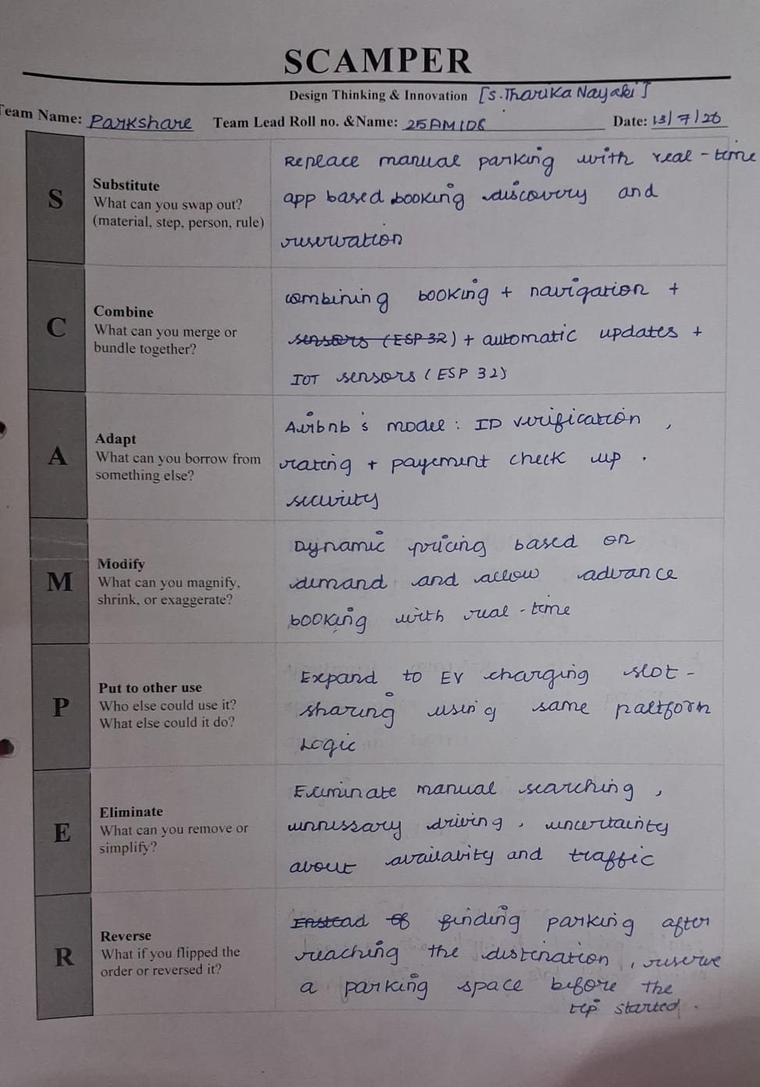
Fig 5.1 SCAMPER Ideation Sheet

5.2.2 Crazy 8’s
Crazy 8’s is a rapid sketching exercise in which a participant explores eight concepts in a short time. Example directions include a single-parking slot camera node, an aggregate monitor, a phone energy card, an event timeline, a demo toggle, a calibration screen, an energy-cost view and a multi-parking space signature display.
Table 5.2 Selected Concepts from Crazy 8’s
S. No. | Concept
1 | Customer dashboard with approved spaces
2 | Separate owner dashboard for parking applications
3 | Administrator approval and decline workflow
4 | Two-slot laptop-camera occupancy detection
5 | Booking and cancellation workflow
6 | Database-backed availability updates
7 | Chatbot for parking questions and supported actions
8 | Nearby parking discovery when location data are available

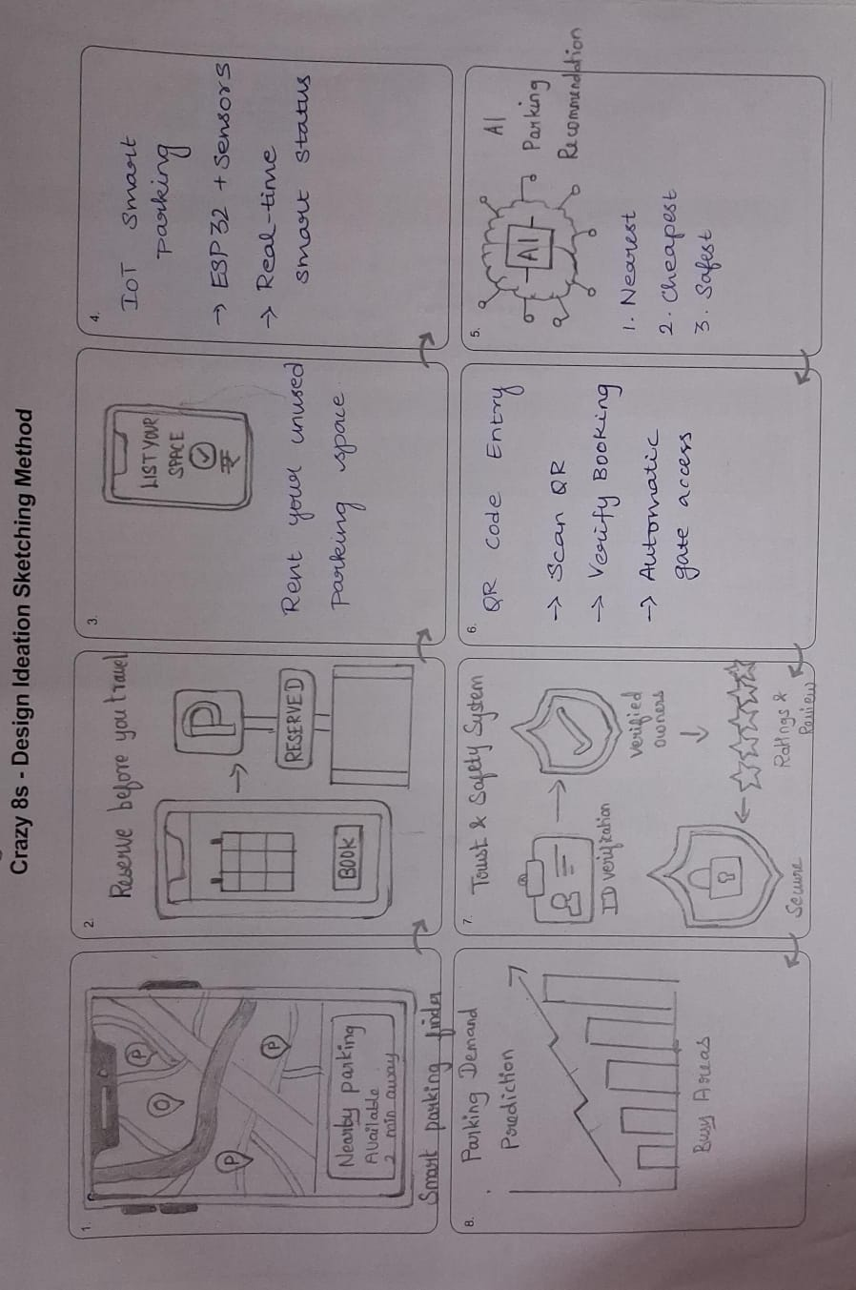 if
Fig 5.2 Crazy 8’s Concept Sketches

5.3 Ideas Generated
Candidate concepts can be screened by feasibility and user value. Manual lists are easy to start but can become stale; a booking-only website improves reservations but may not reflect physical occupancy; a camera-assisted platform combines reservations with a visual occupancy estimate.
Table 5.3 Concept Screening and Feasibility
Concept | Feasibility / limitation
Manual parking list | Simple baseline; availability can become stale
Online booking only | Supports reservations but may not reflect physical occupancy
Two-slot camera-assisted system | Feasible prototype; affected by camera view and lighting
Owner approval workflow | Improves listing control; depends on administrator review
Chatbot integration | Convenient interface; actions must use backend validation

5.4 Selected Concept
The selected concept is the AI-Based Smart Parking Management System: a web application with customer, parking-space owner and administrator roles, a database-backed booking workflow and laptop-camera-based occupancy detection for two parking slots. Owners submit parking details for approval, and customers can view approved listings, book spaces and cancel reservations.
The intended features and current boundaries are:
- Use a laptop camera and configured regions of interest to estimate occupancy for two parking slots.
- Display parking availability and booking status in the appropriate dashboard, and keep customer-facing listings limited to approved spaces.
- Maintain booking and cancellation through the existing backend workflow without replacing or disrupting those functions.
- Store user, parking-space, approval and booking information in a structured database for consistent retrieval.
- Provide a foundation for future expansion to more slots, improved location search, notifications and chatbot-supported actions.
- Use a modular design with role-based access, limited camera visibility and responsible handling of location and account data.

CHAPTER 6

PROTOTYPE – BUILDING THE SOLUTION

6.1 Prototyping Plan
The prototype plan progresses from verifying role-based pages and database records to integrating the camera and testing the complete booking workflow. Each stage should have an acceptance criterion and supporting evidence such as screenshots, logs or test records.
Table 6.1 Prototype Development Plan
Stage | Prototype Activity | Purpose / Exit Criterion
1 | Review current application and database | Confirm existing booking and cancellation flows
2 | Verify customer, owner and administrator roles | Ensure permissions and dashboards are separated
3 | Configure camera and two slot regions | Confirm visible regions and repeatable occupancy tests

6.2 System Architecture / Block Diagram
Figure 6.1 presents the proposed architecture. The laptop camera supplies images to the computer-vision module, which estimates occupancy for the two configured slots. The web frontend communicates with the backend and database for user roles, owner applications, approvals, bookings and cancellations. The chatbot can call supported backend functions rather than modifying database records directly.
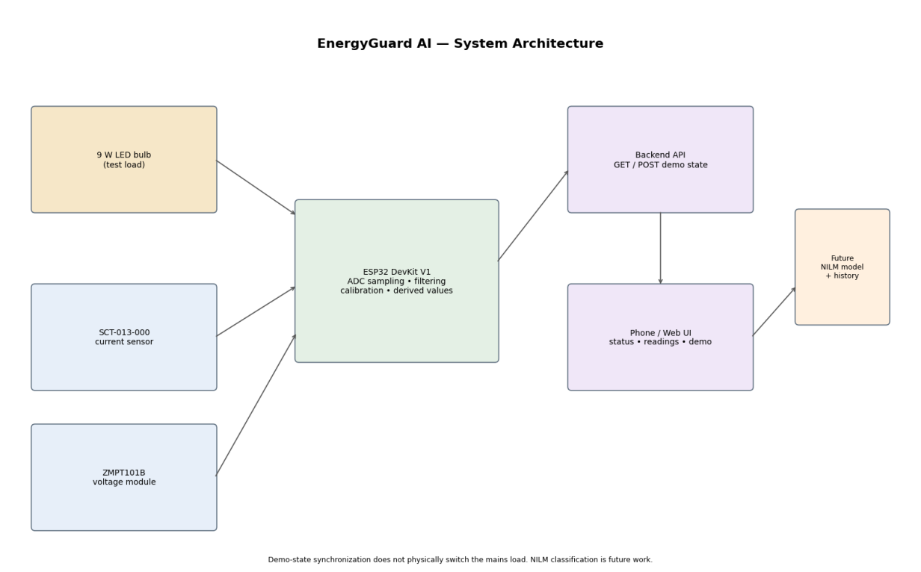
Fig 6.1 Smart Parking System System Block Diagram
- Sensing unit: The Laptop camera detects current through the conductor passing through its split core. The OpenCV/YOLO module provides a voltage-related analog output. Their signals require appropriate burden/biasing, range checks and calibration before meaningful occupancy or power calculations.
- Control and processing unit: The Laptop / web server samples the camera outputs on camera frame-capable pins, performs basic filtering and computes derived quantities when calibration coefficients are available. camera input is used for the voltage camera signal and camera input for the current camera signal in the documented application code configuration.
- Cloud and user interface unit: A backend exposes a booking/occupancy state endpoint (parking and booking backend APIs in the current implementation context). The web application can poll the state, and the mobile/web interface can request available or occupied. The backend response has included fields such as status, demo, on and state. This is a demonstration synchronization mechanism, not a mains switching command.

6.3 Hardware and Software Requirements
The hardware and software resources relevant to the prototype are summarized in Tables 6.2 and 6.3. Exact versions and costs should be updated from the actual project environment and purchase records.
Table 6.2 Hardware Requirements
Component | Specification / Purpose
Laptop camera | Capture parking area for two slot regions
Laptop / computer | Run application and camera-processing module
Camera mount / stand | Keep the view stable and aligned
Network connection | Allow frontend and backend communication
Database | Store users, spaces, approvals and bookings
Power supply | Power laptop and camera as required
Web browser | Customer, owner and administrator interface
Test parking area | Validate occupancy detection
Sample vehicles / labelled frames | Check true and false detections
Enclosure / mounting | Protect and secure camera setup
Optional hosting | Deploy application when configured

Table 6.3 Software Requirements
Software / Tool | Purpose
Python / Flask | Backend routes and application services
OpenCV | Camera access and image processing
YOLO model (if configured) | Vehicle detection in camera frames
Database (project configuration) | Store accounts, spaces and bookings
HTML / CSS / JavaScript | Web interface and dashboards
REST / JSON APIs | Exchange booking, approval and occupancy data

6.4 Design Details
Camera processing: The laptop camera captures the parking area. OpenCV handles image acquisition and region processing, while a YOLO-based detector can identify vehicles if configured in the deployed implementation. The camera must be positioned so the two slot regions are visible; occupancy thresholds and detection behaviour should be validated with real images.
Table 6.4 web application Sensor and Interface Connections
Device | Connection / Area | Interface / Notes
Laptop camera | Camera device index | Capture parking frames
Slot 1 region | Configured ROI | Estimate occupancy for first slot
Slot 2 region | Configured ROI | Estimate occupancy for second slot
Web frontend | Browser | Role-based screens and actions
Backend API | Application routes | Validate booking and cancellation
Database | Configured connection | Persist spaces, approvals and bookings
Owner dashboard | Authorized role | Camera view and owner submissions
Administrator dashboard | Authorized role | Review applications and camera view
Customer dashboard | Customer role | Approved listings and booking actions

Occupancy and booking status: The camera module estimates physical occupancy, while the database tracks reservation status. These are related but distinct states: a booked slot may not yet contain a vehicle, and a detected vehicle does not by itself prove that a booking exists.
Table 6.5 Measured, Derived and Illustrative Parameters
Parameter | Status / Method | Basis / Caution
Camera frame | Image/video frame | Depends on camera availability
Slot 1 occupancy | Detected vehicle in ROI | Validate against labelled frames
Slot 2 occupancy | Detected vehicle in ROI | Validate against labelled frames
Booking status | Database record | Separate from physical occupancy
Listing approval | Administrator decision | Unapproved spaces must not be customer-visible

Camera and backend workflow: Initialize the camera, load the detector, process frames, evaluate the configured slot regions and update the occupancy state through the application backend. Handle unavailable frames, detection errors and stale updates without corrupting booking records.
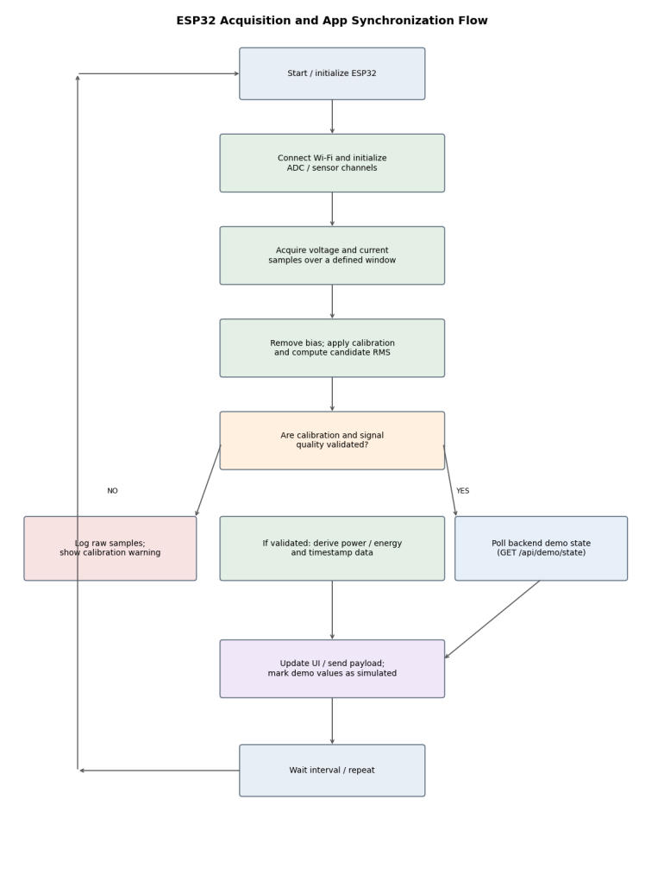
Fig 6.2 web application Sampling and App Synchronization Flow
Future computer-vision improvements may include better vehicle detection in low light, confidence thresholds, region calibration and evaluation on varied parking scenes. Detection accuracy must be measured using labelled test images; no unverified accuracy score is claimed.
Application design: The interface should show current slot status, approval and booking state clearly. Customers should not see the camera feed; the camera module is intended for the owner and administrator views. Booking and cancellation actions must continue to use the existing backend workflow.

6.5 Implementation
The prototype uses a laptop camera for two-slot visual occupancy detection, a web application, a backend service and a database for user, parking-space and booking information. The system has separate customer, owner and administrator workflows. The camera view should be visible only to authorized owner and administrator users.
During implementation and validation, the team should record camera visibility, slot-region alignment, detection behaviour, API responses and database updates. Camera performance may vary with lighting, angle and occlusion, so results should be based on actual test observations rather than assumed accuracy.
Fig 6.3 Photograph of the Smart Parking System Hardware Prototype (to be inserted)
Fig 6.4 Screenshot of the Smart Parking System / Demo Control (to be inserted)

6.6 Cost Estimation
The project cost should be reported from actual bills or purchase records. Reused laptops and cameras should be marked as existing equipment, and software or hosting costs should be recorded only when applicable.
Table 6.6 Prototype Cost Estimate
S. No. | Category | Qty / Basis
1 | Laptop / computer | Existing equipment if reused
2 | Laptop camera | Existing or purchased; enter actual cost
3 | Camera stand / mount | Enter actual quantity and cost
4 | Application development | Record applicable costs only
5 | Database / hosting | Record actual service cost

CHAPTER 7

TEST – VALIDATION AND FEEDBACK

7.1 User Testing
Testing should separate camera occupancy detection, backend/database integration and user-interface behaviour. Role permissions, owner approval, booking/cancellation and chatbot operations should be tested independently and then as an integrated workflow. Any pass/fail result should be supported by a test log.
Table 7.1 Functional Test Plan and Observed Status
S. No. | Test Case | Expected Result | Observed Status
1 | Customer login and role access | Customer dashboard opens; owner/admin pages restricted | To be recorded
2 | Owner submits parking space | Application is stored for review | To be recorded
3 | Administrator approves/declines | Decision updates application status | To be recorded
4 | Customer booking | Booking is stored and availability updates | To be recorded
5 | Customer cancellation | Booking is cancelled and status updates | To be recorded
6 | Camera occupancy | Slot state matches labelled test scene | To be tested
7 | Camera visibility | Only owner/admin can access camera view | To be tested
8 | Chatbot booking/cancel | Action uses backend validation and confirms result | To be tested

7.2 Results and Performance Analysis
System evaluation should establish whether the web application, database and camera module work together as expected. Record actual results for camera-based occupancy, approved listing visibility, booking/cancellation consistency and role restrictions. Do not claim perfect detection or full deployment readiness without supporting tests.
Table 7.2 Illustrative Energy Calculation Example
Example | Power input (illustrative) | Duration | Energy result | Status
Hypothetical constant load | 9 W (nominal label, not measured) | 2 h | 18 booking records = 0.018 booking status | Calculation example only
Measured prototype result | Enter calibrated measured power | Enter test duration | Compute from measured power trace | Pending
Acidic sample | 4.80 | 4.93 | 1650 | 1712
Alkaline sample | 9.60 | 9.48 | 1890 | 1836
High-TDS sample | 7.10 | 7.21 | 2600 | 2697

For illustration only, a booking test can use a defined slot, customer account and time period to check whether the reservation is stored once and the interface updates consistently. This is a test scenario, not a claim that all test cases have passed.
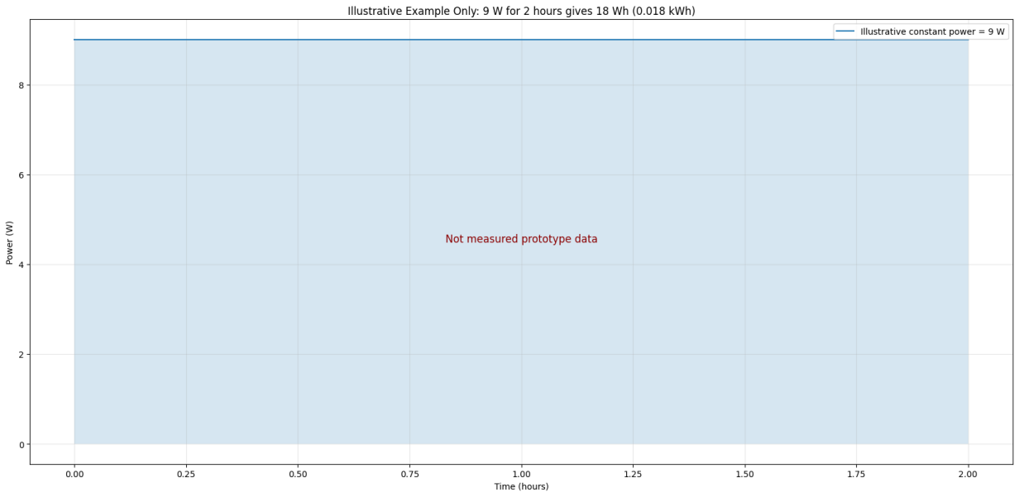
Fig 7.1 Illustrative Parking Status and Booking Flow (illustrative)
The following performance indicators should be measured during formal validation:
- Camera detection: compare predicted slot occupancy against manually labelled frames and record false positives, false negatives and detection delay.
- Booking consistency: verify that successful bookings update availability and that cancellation restores the correct status.
- Database reliability: check that owner applications, administrator decisions, customer bookings and cancellations persist correctly.
- Role and access control: verify that customers cannot access owner/admin camera views and that unapproved spaces do not appear in customer listings.
- Connectivity: record API success rate, update delay, recovery after network interruption and whether stale occupancy is clearly indicated.

7.3 Feedback and Refinement
Feedback should be collected by asking customers, owners and administrators to complete representative tasks without coaching. Record what is clear or confusing about availability, booking, cancellation, owner submission and approval.
Table 7.3 Feedback and Improvement Grid
Positive aspects to check | Risks / criticisms to investigate
Two-slot setup is manageable for a prototype | Detection can fail due to lighting or occlusion
Online booking can reduce repeated enquiries | Stale status or duplicate requests must be handled
Owner approval can improve listing quality | Administrator review may delay publication

Expected refinements include clearer available/occupied/booked labels, better camera placement guidance, visible update times, robust handling of camera or network failure, improved location search and a chatbot that confirms actions only after the backend reports success.

7.4 Technology Readiness Level (TRL) Assessment
Technology Readiness Level is a scale used to describe technology maturity. Based on the available project context, this system should be described according to the functions actually demonstrated: the role-based workflow and booking features are distinct from the camera detection features, and each requires its own validation evidence.
Table 7.4 TRL Assessment of Smart Parking System
TRL | Description | Project status (provisional)
1 | Basic principles observed | Parking workflow and computer-vision concepts reviewed
2 | Technology concept formulated | Role-based architecture and two-slot plan defined
3 | Experimental proof of concept | Status depends on demonstrated booking and camera artefacts
4 | Validated in laboratory | Requires repeatable camera and workflow tests
5 | Validated in relevant environment | Requires testing in a realistic parking setting

Before claiming a higher readiness level, the team should complete repeatable camera tests, role-permission checks, owner approval tests, booking/cancellation validation, database error handling and evaluation in a realistic parking environment.

CHAPTER 8

IMPACT AND SUSTAINABILITY

8.1 Mapping to Sustainable Development Goals (SDGs)
Smart parking can support more efficient use of existing parking spaces by helping drivers discover available spaces and enabling owners to list unused areas. Any reduction in search time, congestion or emissions should be measured in a real deployment rather than assumed.
Table 8.1 Mapping of the Smart Parking Project to SDGs
SDG | Potential Contribution
SDG 11 – Sustainable Cities and Communities | May improve access to existing parking spaces; real impact must be measured
SDG 12 – Responsible Consumption and Production | Can support more efficient use of underused parking areas

8.2 Deployment and Sustainability Model
A sustainable deployment concept could offer a web application for customers and space owners, an administrator review workflow, camera-assisted occupancy and support for maintaining listings. The design should prioritize usability, privacy, repairability and transparent availability status. Market demand and operating costs should be assessed before making business claims.
Fig 8.1 Smart Parking Deployment Concept
Table 8.2 Deployment / Sustainability Model
Building Block | Proposed Description (to validate)
User segments | Drivers, parking-space owners and administrators
Value proposition | Approved listings, booking/cancellation and camera-assisted status
Channels | Web application and supported chatbot interface
Customer relationship | Clear status, booking history and owner support
Revenue / sustainability | To be assessed; no validated pricing or market demand claimed
Key resources | Application code, database, laptop camera and detector
Key activities | Listing review, booking management, occupancy testing and support
Key partners | Parking owners, test users and deployment/support team
Cost structure | Development, hosting, camera mounting and maintenance

CHAPTER 9

CONCLUSION AND FUTURE SCOPE

9.1 Conclusion
This project presents an AI-Based Smart Parking Management System that combines role-based access, parking-space listings, administrator approval, customer booking and cancellation, and laptop-camera-based occupancy estimation for two parking slots. The platform is designed to help customers find approved spaces while allowing owners to submit unused parking areas for review. The camera module is intended for owner and administrator views, and the chatbot can provide an additional interface for supported parking queries and booking actions.
The project should not be treated as a fully validated large-scale parking deployment. Camera detection can be affected by lighting, angle and occlusion, and the two-slot prototype does not establish performance across all parking environments. Booking records, physical occupancy and administrator approval represent different states and must be displayed clearly. The system should be evaluated through documented tests before claiming reliability.
The principal outcome is a structured starting point for a smart parking platform with separate user roles and a camera-assisted occupancy workflow. Completing systematic testing, improving error handling and evaluating the system in realistic conditions will be necessary before wider deployment.

9.2 Future Scope
The following improvements are recommended:
- Evaluate camera occupancy against manually labelled images under different lighting, camera angles and vehicle positions.
- Improve synchronization between camera status, database availability and booking/cancellation updates.
- Collect labelled parking images and evaluate vehicle detection using precision, recall, F1-score and detection delay.
- Add stronger location-based search, notifications, booking history, owner analytics and reporting where required.
- Improve authentication, role-based authorization, API validation, database recovery, camera-failure handling and privacy controls.
- Expand beyond two slots only after the current workflow is validated, and document camera installation, data retention and deployment procedures.

REFERENCES
[1] OpenCV, “OpenCV Documentation,” official documentation for image acquisition, video capture and image processing.
[2] Ultralytics, “YOLO Documentation,” official documentation for object detection and model configuration. Cite the exact model version used.
[3] Flask, “Flask Documentation,” official documentation for routing, request handling and web application development.
[4] MySQL, “MySQL Reference Manual,” documentation for relational data storage and database operations, if MySQL is the database used.
[5] MDN Web Docs, HTML, CSS and JavaScript documentation for the web interface.
[6] OWASP Foundation, “Application Security Verification Standard” or relevant access-control guidance for role-based web applications.
[7] Use the actual computer-vision model, database and framework documentation matching the deployed source code.
[8] Add verified research papers on camera-based parking occupancy detection and smart parking management that were actually consulted.
[9] Cite the actual project repository or implementation documentation if permitted by the institution; do not use AI tools as technical evidence.
[10] Add verified references for privacy, image handling and responsible use of camera-based monitoring, if discussed in the final submission.
[11] J. C. Mankins, “Technology readiness assessments: A retrospective,” Acta Astronautica, vol. 65, no. 9–10, pp. 1216–1223, 2009.
[12] United Nations, “Sustainable Development Goals,” official SDG documentation.
[13] A. Osterwalder and Y. Pigneur, Business Model Generation, Wiley, 2010. Use only if a Business Model Canvas is included in the final submission.

ANNEXURE

PROJECT TITLE | CARBNB – A peer to peer AI Based Parking System
PROGRAM | B.E. CSE(AIML)
PROJECT BATCH NUMBER
BATCH MEMBERS | 25AM116 | Veyelunthal Esakkiammal R
 | 25AM108 | Tharika Nayaki S
 | 25AM113 | Vaishnavi S
NAME OF THE SUPERVISOR | Dr.S.Sumathi M.E .,Ph.D
NAME OF THE SDG GOALS MAPPED | Industry, Innovation and Infrastructure , Sustainable cities, and communitites
MENTION THE SDG GOALS NUMBER | SDG 9, SDG 11
NAME OF THE TRL LEVEL
MENTION THE TRL LEVEL
POs & PSOs Mapping (Put a tick mark in the mapped PO’s & PSO’s):
Program Outcomes |  |  |  |  |  |  |  |  |  |  | Program Specific Outcomes
PO1 | PO2 | PO3 | PO4 | PO5 | PO6 | PO7 | PO8 | PO9 | PO10 | PO11 | PSO1 | PSO2
✓ | ✓ | ✓ |  | ✓ | ✓ | ✓ | ✓ | ✓ | ✓ | ✓ | ✓ | ✓

Signature of the Students

VENUE AND EXPENDITURE STATEMENT FOR THE PROJECT WORK
Laboratory details where the project is carried out | Enter actual lab, department and institution
Software / Hardware details | Hardware: Laptop / web server, Laptop camera current camera, OpenCV/YOLO voltage module, two parking slots. Software: web application application code, backend booking/occupancy state API and app interface. Add exact versions and actual tools.
Details of the Component and Expenditure
S. No | Name of the Component | Qty | Price / Unit in (Rs.) | Amount (Rs.)
1 | Arduino Uno board | 1 | ₹800 | ₹800
2 | HC-SR04 ultrasonic distance sensor | 2 | ₹200 | ₹400
3 | Servo motor for automatic gate | 1 | ₹150 | ₹150
4 | Breadboard | 1 | ₹60 | ₹60
5 | Jumper wires | As purchased | ₹50 | ₹50
6 | USB / regulated power supply | As purchased | ₹0 | ₹0
7 | Parking-slot model, gate barrier and mounting materials | If purchased | ₹0 | ₹0
8 | Laptop for Arduino programming and dashboard | As purchased | ₹0 | ₹0
9 | Total
  ₹1,460

Signature of the Students | Signature of the Supervisor

APPENDIX A — CAMERA SETUP AND OCCUPANCY VALIDATION
Purpose. Use this worksheet to document the camera setup and occupancy-detection process. Record the camera device, position, slot-region coordinates, detector/model version, date and test conditions.
Camera setup. Record the camera index, resolution, frame rate, mounting position and field of view. Confirm that both parking slots are visible and that the configured regions of interest align with the physical spaces.
Occupancy validation. Capture examples of empty slots, occupied slots, partial occlusion and changing light conditions. Compare predicted status with a manually labelled result. Do not report an accuracy percentage until a sufficient number of labelled test frames have been evaluated.
Validation record fields: camera identity; camera position; image resolution; slot 1 region; slot 2 region; model/version; lighting condition; manually labelled status; predicted status; confidence if available; timestamp; and evidence reference.
Acceptance criteria should be defined before testing. For example, specify the required detection precision/recall, acceptable update delay and expected behaviour when the camera is unavailable. Record untested cases as Pending.

APPENDIX B — PARKING OCCUPANCY AND BOOKING STATUS
Parking occupancy is estimated from camera frames. For each configured slot region, the computer-vision module checks whether a vehicle is detected within the region and updates the estimated status. The exact algorithm and confidence threshold must match the implementation.
Occupancy status = detected vehicle within configured slot region (subject to validation).
The detected status depends on camera angle, lighting, occlusion and model performance. Compare automated predictions with manually labelled frames. Do not interpret a booking record as proof that a vehicle is physically present.
Booking state and physical occupancy are separate. A slot can be booked before the vehicle arrives, and a vehicle may be detected without a corresponding reservation. The interface and backend should keep these states distinct.
For a booking test, record the selected slot, customer, booking time, booking status and cancellation outcome. Confirm that the database stores one valid reservation and that the customer-facing availability updates consistently.
Illustrative test only: book Slot 1 using a test account, verify the booking record and status, then cancel the booking and confirm that the slot becomes available again when no other booking prevents it. This is a test scenario, not a claim that every test has passed.
The report should state the camera configuration, detector/model version, region coordinates, test conditions, number of labelled frames, evaluation method, results and limitations. Do not invent accuracy scores or claim perfect detection.

APPENDIX C — PARKING BACKEND API AND CHATBOT ACTIONS
The backend API supports the application workflow for parking-space listings, administrator decisions, bookings, cancellations and occupancy updates. Chatbot actions should call validated backend functions and must not write directly to the database or bypass access checks.
Availability endpoint. Expected purpose: return the current approved parking listings and relevant availability/booking state. Document the actual route, response fields and authentication requirements from the deployed implementation.
Booking/cancellation endpoints. Expected purpose: validate the requested customer action, check slot availability and booking rules, persist the result and return a clear success or error response. Use the actual routes and request body defined by the project.
Recommended behaviour: validate input and user permissions; prevent duplicate or conflicting bookings; keep customer, owner and administrator views consistent; handle timeouts and database errors; and confirm an action only after the backend reports success.
A future occupancy endpoint may accept slot ID, detected status, confidence if available, timestamp and camera/model identifier. The server should validate values and keep physical occupancy separate from reservation status.
For a formal API test, record request method, route, payload, response code, response body, user role, timestamp and whether the interface updated. Redact passwords, tokens and private URLs from screenshots.

APPENDIX D — FUNCTIONAL VALIDATION CHECKLIST
Use this checklist to validate the integrated parking application. Each test should have a date, setup, expected outcome, actual observation and evidence reference.
1. Application startup: verify the web app and backend start correctly. 2. Role access: check customer, owner and administrator permissions. 3. Owner application: submit a space and verify it remains hidden from customers until approved. 4. Booking: reserve an available slot and confirm the database/UI update. 5. Cancellation: cancel a booking and verify the status. 6. Camera: test empty and occupied scenes for both configured regions. 7. Privacy: verify the camera view is restricted to owner/admin. 8. Chatbot: test availability questions and supported booking/cancellation intents. 9. Failure handling: test camera/network/database errors.
Do not mark a test Pass merely because the screen looks correct. A pass requires the expected behaviour and supporting evidence. Tests that have not been conducted should remain Not tested or Pending.

APPENDIX E — HIGH-LEVEL PARKING SYSTEM WORKFLOW
The following high-level workflow is illustrative and must be checked against the actual source code. It is not a replacement for the implementation.
SETUP:
initialize application and database connection
load camera device and configured slot regions
load the configured vehicle detector if available
initialize customer, owner and administrator routes
validate configuration and permissions
handle camera startup failure without breaking booking pages
LOOP:
capture a camera frame when the camera module is enabled
detect vehicles in the frame
evaluate detections against Slot 1 and Slot 2 regions
update estimated occupancy with a timestamp
keep occupancy status separate from booking status
render camera access only for authorized owner/admin roles
for customer actions, validate account and slot availability
create or cancel bookings through backend routes
for owner applications, store submitted parking details as pending
for administrator actions, approve or decline pending applications
chatbot validates intent and calls the same supported backend functions
display confirmation only after a successful backend response
handle timeout, camera failure and database errors gracefully
Important implementation details to document: framework and version, database schema, API routes, authentication/authorization, camera index.

APPENDIX F — CAMERA PRIVACY AND RESPONSIBLE DEMONSTRATION
This project uses a camera to monitor a parking area. Camera images and location/booking data may be sensitive. Limit camera access to authorized parking owners and administrators, and explain how images and account information are handled. The report does not certify the application for commercial deployment.
Before demonstration, confirm that the camera is securely mounted, both slot regions are visible and the camera feed is not exposed to customer accounts. Review account permissions and avoid displaying private credentials, access tokens or personal data.
Use a stable camera position and secure mounting. Keep cables out of walking and driving paths. Restrict access to the camera screen and store only the information required for the project. Test how the application behaves when the camera or network is unavailable.
The camera module estimates physical occupancy; it does not itself create or cancel a reservation. Booking and cancellation must continue through the existing backend workflow, and chatbot actions must use the same validation and authorization rules.
For the final presentation, demonstrate empty and occupied slot examples, the customer booking/cancellation workflow, owner submission, administrator approval and role-restricted camera view. Clearly label untested functions and use real screenshots from the project.

APPENDIX G — FUTURE Smart Parking DATASET AND EVALUATION PROTOCOL
A future parking detector should be evaluated on a labelled dataset covering empty and occupied slots, different vehicle types, daylight and low-light conditions, varied camera angles and partial occlusion. Split data into separate training, validation and test sets where model training is performed.
Use repeated trials and record both successful and failed detections. Keep test frames separate from any data used to tune thresholds or train the model. Document the camera position, slot boundaries, scene conditions and labelling method.
Candidate evaluation measures include precision, recall, F1-score, false-positive rate, false-negative rate and detection delay. Report results separately for Slot 1 and Slot 2 and across relevant lighting conditions.
For the booking workflow, report successful booking/cancellation rate, duplicate-booking prevention, approval visibility, API response time and role-access test results. For camera detection, report results against manually labelled frames rather than estimated claims.
A useful next experiment is to compare the configured detector with a simple baseline across a fixed set of labelled frames. If performance is weak, review camera placement, region coordinates, confidence thresholds and the diversity of the test data before expanding to more slots.

